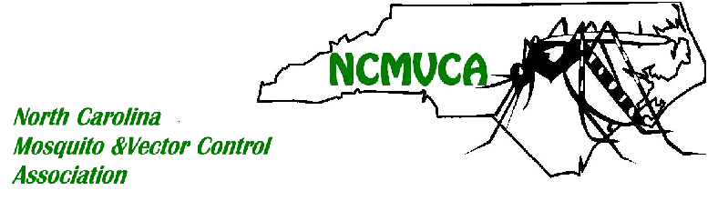
Awards

The North Carolina Mosquito & Vector Control Association Recognizes the outstanding
contributions of its members by conferring the following awards: Hamilton W. Stevens
Award and the William F. Strickhouser (formerly Golden Dipper) Awards.

The Hamilton W. Stevens Award:

Dr. Hamilton W. Stevens was a past president of the Association and a tireless advocate for mosquito control and public health. This award honors those individuals who have made outstanding contributions to the organization its mission and objectives, following the high standards set by Dr. Stevens. The NCMVCA has been proud to select the following individuals for the Hamilton Stevens Award.

1986: Dr. Nolan Newton
1987: Jim Bryan
1988: Dr. Charles Apperson
1989: William F. Strickhouser
1990: Bobby Waters
1991: Mitchell Parker
1995: Dennis Salmen
1996: Pat Simmons
1997: Peter Connelly, Jeff Brown, Ken Sholar
1998: Rick Hickman
1999: Bruce Harrison
2000: Joe Strickhouser
2001: Dennis Salmen
2003: Jeff Brown
2004: Walker Rayburn, Jr.
2005: Jim Bryan
2006: Joe Andrews
2007: Parker Whitt
2008: Marcée Toliver
2011: Jeff Brown
2013: Tommy Bowen
2014: Dr. Jung Kim
2016: Robert Collins
2018: Dr. Brian Byrd, James Gardner
2020: Stephanie Richards

William F. Strickhouser (formerly Golden Dipper) Award:

Started in 2006, the Golden Dipper Award is conferred to the Vector Control Operator or
Technician that has demonstrated outstanding efforts during the year. Field personnel
are the backbone of the organization, and the recipients of the Golden Dipper Award are the cream of the crop! In 2009, the Golden Dipper Award was renamed to be the William F. Strickhouser Award. Mr. Strickhouser was a founding and honored member of this association throughout his life. Mr. Strickhouser started the first and only full service business serving mosquito control in North Carolina at the time, the William. F. Strickhouser Company. In this capacity, he was an asset to local mosquito control programs for many years, selling and maintaining many generations of equipment through the years. This included a variety of thermal foggers, Buffalo Turbine mister/dusters and ending with London Fog ULV spray equipment – some of the latter are still in use today! His impact on the local programs and their people has demonstrated the meaning of values and professionalism in the field of mosquito control. Recipients of the William F. Strickhouser Award are truly the ‘best of the best’!

2006: Sidney Wilkins
2008: Ryan Harrison and Neal Williams
2009: Joe Strickhouser and Jeff Wells
2012: John R. Faulkner
2018: Keith Studt, Octavius “OJ” James
2020: Neill Cagle, Nathan K. Godbey

